**SOFTWARE**

**USER’S  
MANUAL**



Payroll Management System

Fall 2018

Copyright © 2018 by Nicholas Borghese, Vincent Ippolito, Carl Mendez, Ilya Shvabskiy, Nick Wilson

All rights reserved. No part of this publication may be reproduced, distributed, or transmitted in any form or by any means, including photocopying, recording, or other electronic or mechanical methods, without the prior written permission of the publisher, except in the case of brief quotations embodied in critical reviews and certain other noncommercial uses permitted by copyright law. For permission requests, write to the publisher, addressed “Attention: Permissions Coordinator,” at the address below.  
  
Express Medical

5500 Hylan Blvd.

Staten Island, NY 10306  
www.vbaggz.com  
  
Printed in the United States of America  
  
First Printing, 2018

ISBN 921-5-2310150-8-8

**USING THESE MANUALS**

The two manuals included are for Express Medical

1. Administrator’s Use

*“Software User's Guide” (this manual)*

This guide explains the usage and functions of the software. You will also see how to gain access to our software via a local host.

1. Non-Administrators Use

*“Software Training Manual”*

This guide teaches the user a step by step demonstration in how to use our software.

**How to use the Software User Guide**

Display examples:

The screenshots used in the explanations are the same as the actual display screens.

Terminology:

In this guide, user means the person currently using the software.

SOFTWARE USER'S MANUAL  
TABLE OF CONTENTS

1. 0 GENERAL INFORMATION………..……………………………………...……………………………..5

1.1 System Overview...………..……………………………………...…………………………... 5  
 1.2 Reporting a Problem………………………….………………….…………….…………….. 5  
 1.3 Organization of the Manual………………………………....…………………………… 5  
 1.4 Acronyms and Abbreviations………………………………………..………………….. 6

2.0 SYSTEM SUMMARY………………………………..……………………………………………………… 7

2.1 System Configuration…………………..…………………………………………………… 8  
 2.2 Data Flows…………………...……………………………………………………………………. 8  
 2.3 User Access Levels………………..…………………………………………………………… 9  
 2.4 Contingencies and Alternate Modes of Operation………….………………… 10

3.0 GETTING STARTED…………………………………….………………………………………………….. 11

3.1 Logging On…………………………………...……………………………………………………. 12  
 3.2 System Menu ……………………………………………….…………………………………….. 12  
 3.3 Functionality..…………………………………………………..………………………………..14

3.4 Exit System………………………………………………………...……………………………… 17

4.0 USING THE SYSTEM ........................................................................................................... 18

4.1 Admin……………………………………....…………………………………………….…………..19

1.0 GENERAL INFORMATION

**1.0 GENERAL INFORMATION  
  
1.1 System Overview**

This web application is designed to be a payroll management system, where it keeps track of its employees and their pay stubs. Our software will give employees access to their pay stubs at any given time.

Our payroll management system is a full stack web application that will be developed using HTML5, CSS3,Bootstrap, JavaScript and PHP for the frontend, and PHP, Javascript and SQL for the backend.

In our software, certain access is granted to based on what you are classified as: administrator, HR-representative, or employee, The main tasks our software can perform are searching, adding, editing, and deleting data.

**1.2 Reporting a Problem**  
  
If any bugs arise, please contact our helpdesk at (347) 555-8921 or vbaggz.website@gmail.com for further assistance.

**1.3 Organization of the Manual**  
  
Progressing into this document, we will provide:

* System Summary
* Getting Started
* Using the System
* Quearies

**1.4 Acronyms and Abbreviations**

1. **CSS3:** “Cascading Style Sheets”, a style language that defines how a website is presented to the user.
2. **HTML5:** “Hypertext Markup Language”, the latest version to code/create a website.
3. **PHP:** “Hypertext Preprocessor”,is a backend and is designed for web development.
4. **SQL:** “Structured Query Language”, is a a backend and is designed for web development.

2.0 SYSTEM SUMMARY

**2.0 SYSTEM SUMMARY**  
  
**2.1 System Configuration**

Medical Express operates only on the web. The application requires connection to Internet in order to save and obtain data from the database. Data saved in database can be seen using any major Internet browser.

**2.2 Data Flows**

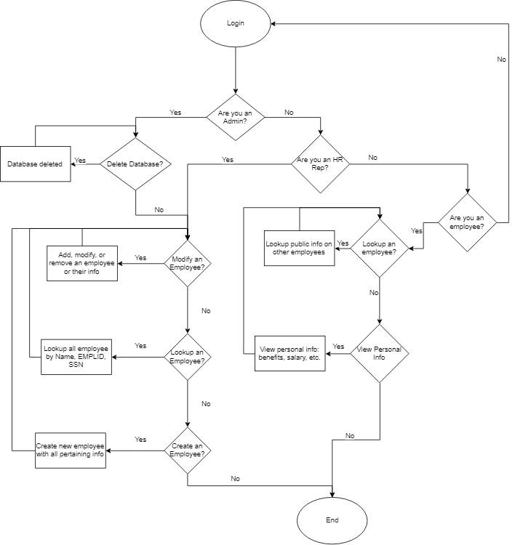

Upon logging in, the user will be identified as one of our 3 types of users: administrator, HR-rep, or employee. The type the user is will be kept in mind while they are logged on. Our flowchart shows what tasks each type of user can perform.

Data received from these user interfaces are stored in a database that contains three tables which are: Employee_Records,Employee_Finance, and Healthcare:

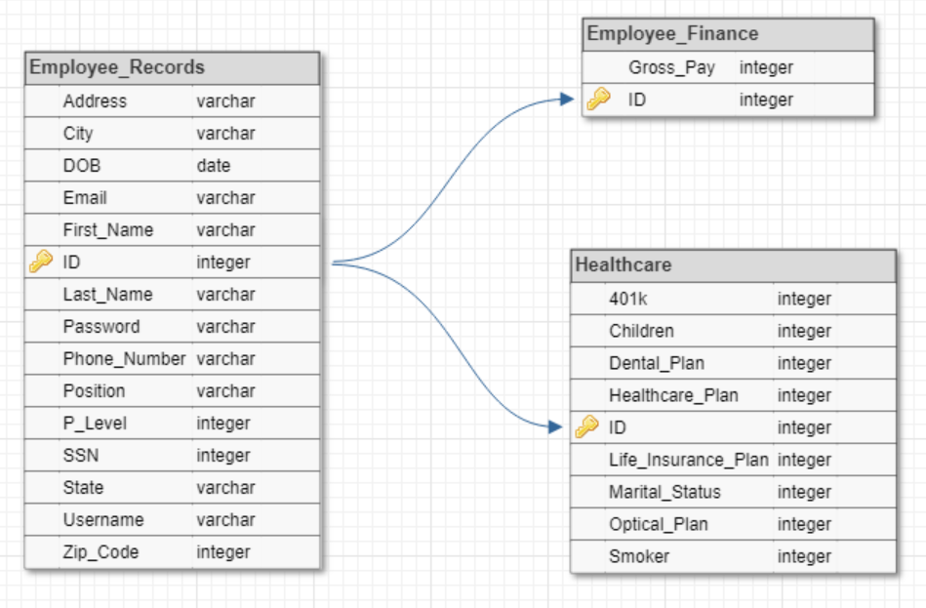

**2.3 User Access Levels**

As mentioned in 2.2, there are 3 possible types of users if there is a successful login.

* *Administrator:* this is the highest level of access; all components of our software can be used here.
  + delete a database
  + modify an employee
  + lookup an employee
  + create an employee
  + delete an employee
* *HR-Representative:* this is the middle level of access; this type differs from the administrator by not being able to remove people from the database or delete the database entirely
  + modify an employee
  + lookup an employee
  + create an employee
* *Employee*: this is the lowest level of access; this type differs from the manager by not being able to create/edit/search employees.
  + view their personal information

**2.4 Contingencies and Alternate Modes of Operation**In case of power outage, data is not saved in internal memory of the operating device. In case there is no Internet connection available, data  
cannot be saved in internal memory of the operating device.

3.0 GETTING STARTED

**3.0 GETTING STARTED**

**3.1 Logging On**

Username and password are required to use this web app.

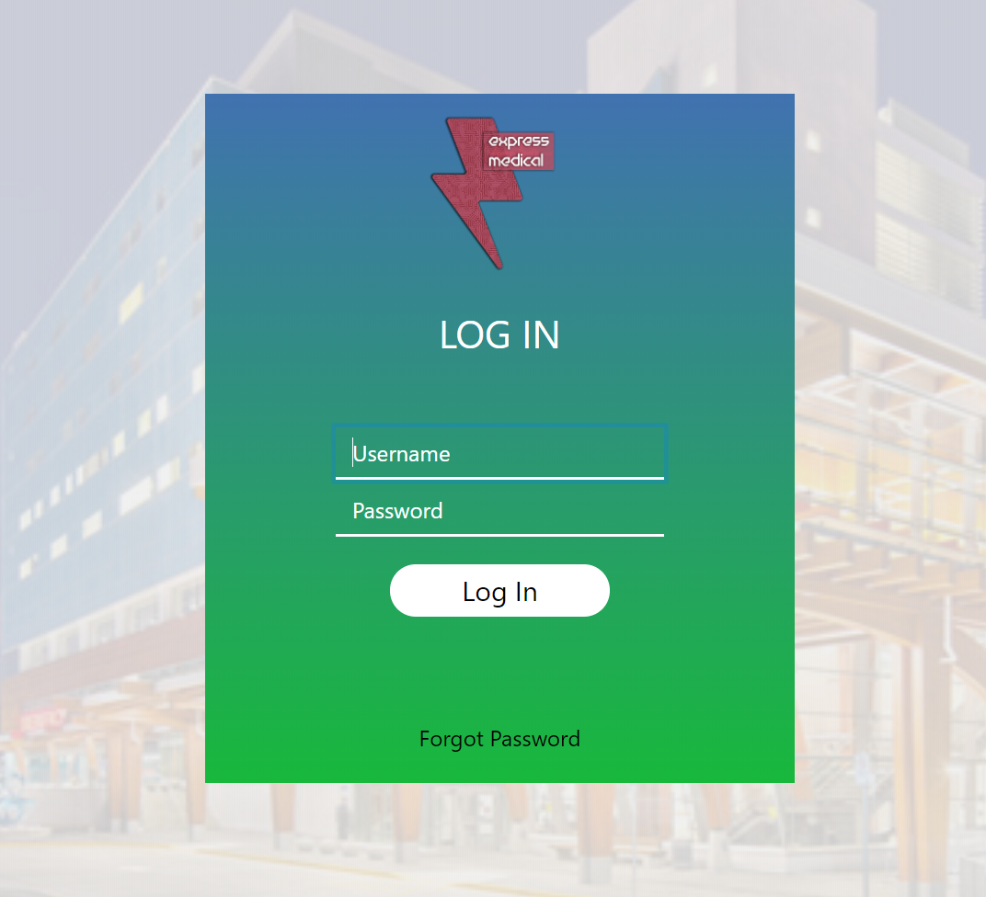

**3.2 System Menu**

Medical Express is tabbed application, which consists of at most 9 tabs (Figure 1) depending on the user. This example will show an admin’s page because they have access to every tab.

* First tab is the home page. Medical news will be displayed here.
* Second tab has info of the user consisting of: ID, name, date of birth, email, address, position, phone number, marital status, children, healthcare plan, dental plan, optical plan, life insurance, and 401k
* Third tab handles editing an employee's benefits; this is where an admin or HR-rep can edit an employee’s benefit plans
* Fourth tab has information on finances; this is where users can view their pay stub and see all the money taken out from taxes and benefits. Employees can also print their pay stubs from this page.
* Fifth tab handles adding an employee. admins and HR-reps can add new employees to the database here.
* Sixth tab handles editing employees; this is where admins and HR-reps can edit existing employees.
* Seventh tab handles deleting an employee. Only admins can delete an employee from the database.
* Eighth tab allows any type of user to search for other employees and see information on how to contact them.
* Ninth tab simple logs the user out of the website.
* **NOTE**: Only on employee users (not admin or HR-reps), the “My Info” tab has been split into two separate tabs. These tabs are “My Info” and “My Benefits”. My Info displays ID, name, date of birth, email, address, position, and phone number. My Benefits displays ID, marital status, children, healthcare plan, dental plan, optical plan, life insurance, and 401k.

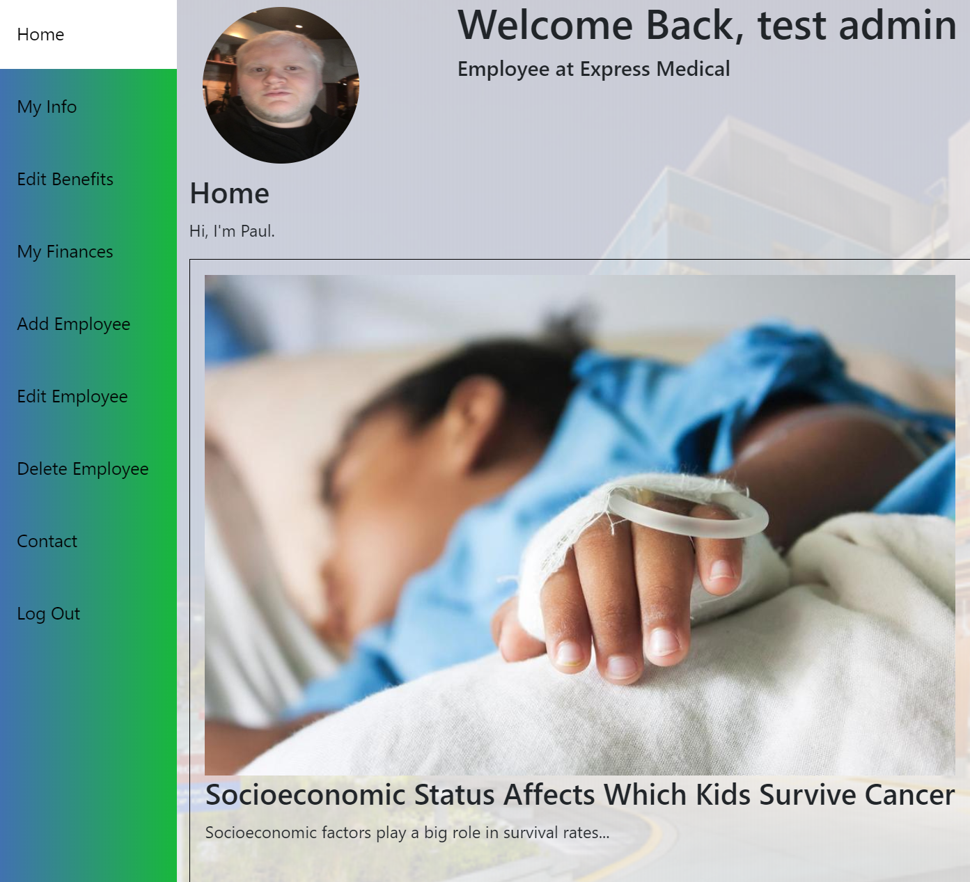

**Figure 1.** Tabs of Express Medical

**3.3 Functionality**

**3.3.1 Add**

For your employees, HR-reps, and other fellow administrators to use this software, an account must be made for them by either an administrator or an HR-rep. Please provide the person their login credentials as you hand them a trainers manual.

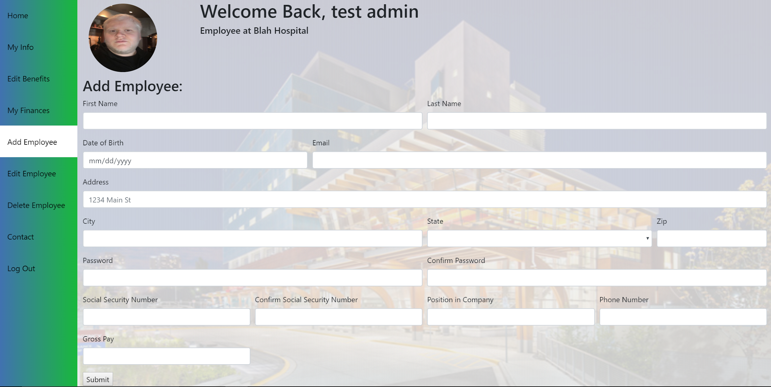

**Figure 2.** Add Employee-tab

**3.3.2 Edit Employee**

A person must be searched by employee ID. If the employee is found then it will display a menu identical to the Add Employee tab (**Figure 3**). It will be filled in with all the information of the searched employees.

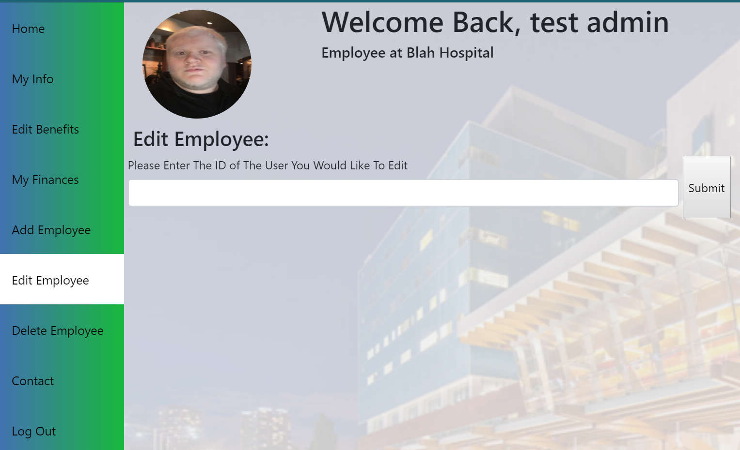

**Figure 3.** Edit Employee-tab

**3.3.3 Edit Benefits**

A person must be searched by employee ID. If the employee is found then it will display a menu (**Figure 4**). It will be filled in with all the information of the searched employees.

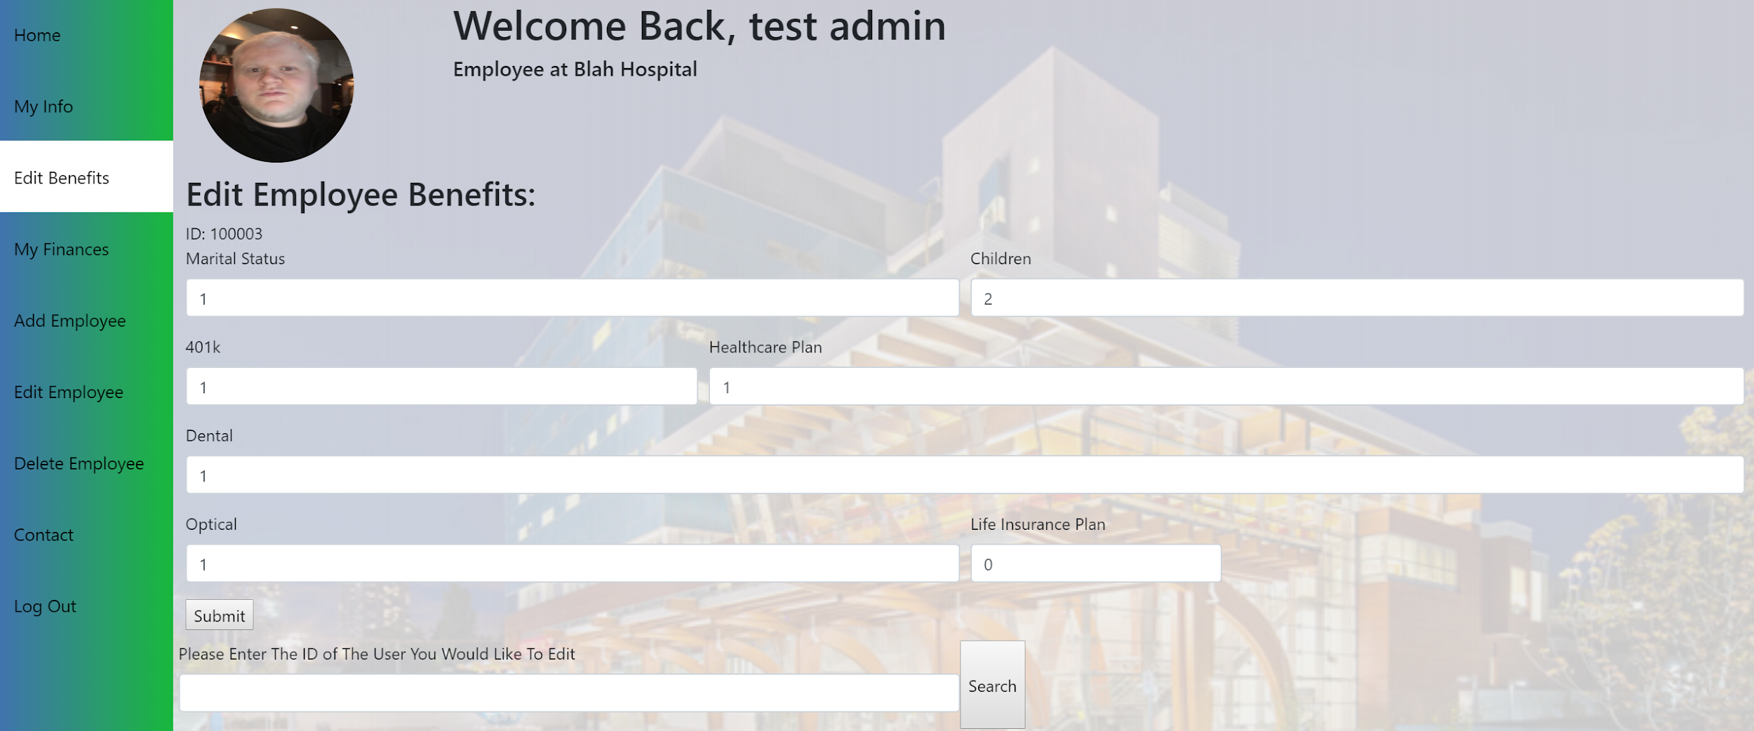

**Figure 4.** Edit Benefits-tab

**3.3.4 Delete**

A person must be searched by employee ID. If the employee is found then then they can be selected and deleted from the database (Admin privilege only).

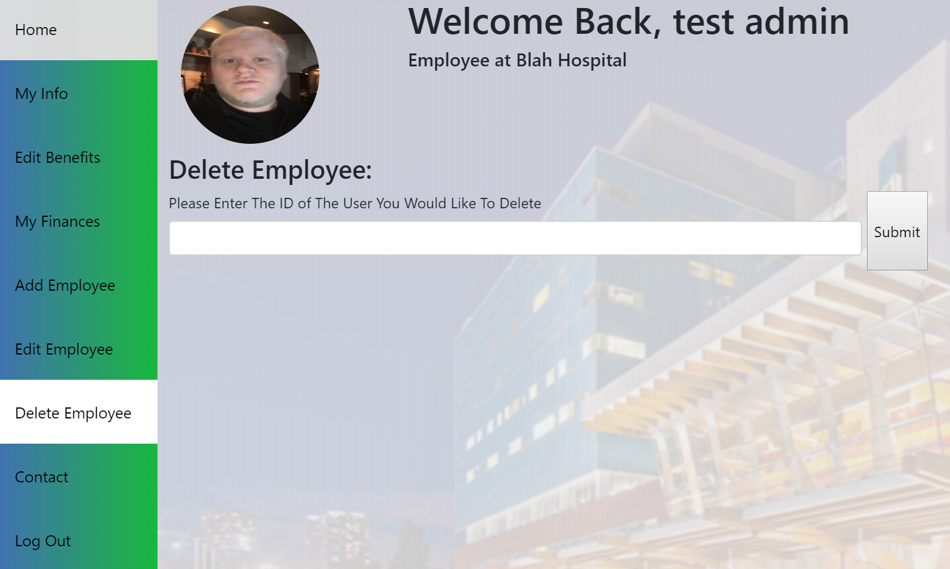

**Figure 5.** Delete Employee-tab

**3.3.5 Contact**

A person can be searched by employee ID, name, position, or phone number. If the employee is found then any of the information they are searchable by is displayed. By default, all employees are displayed before typing into the search bar.

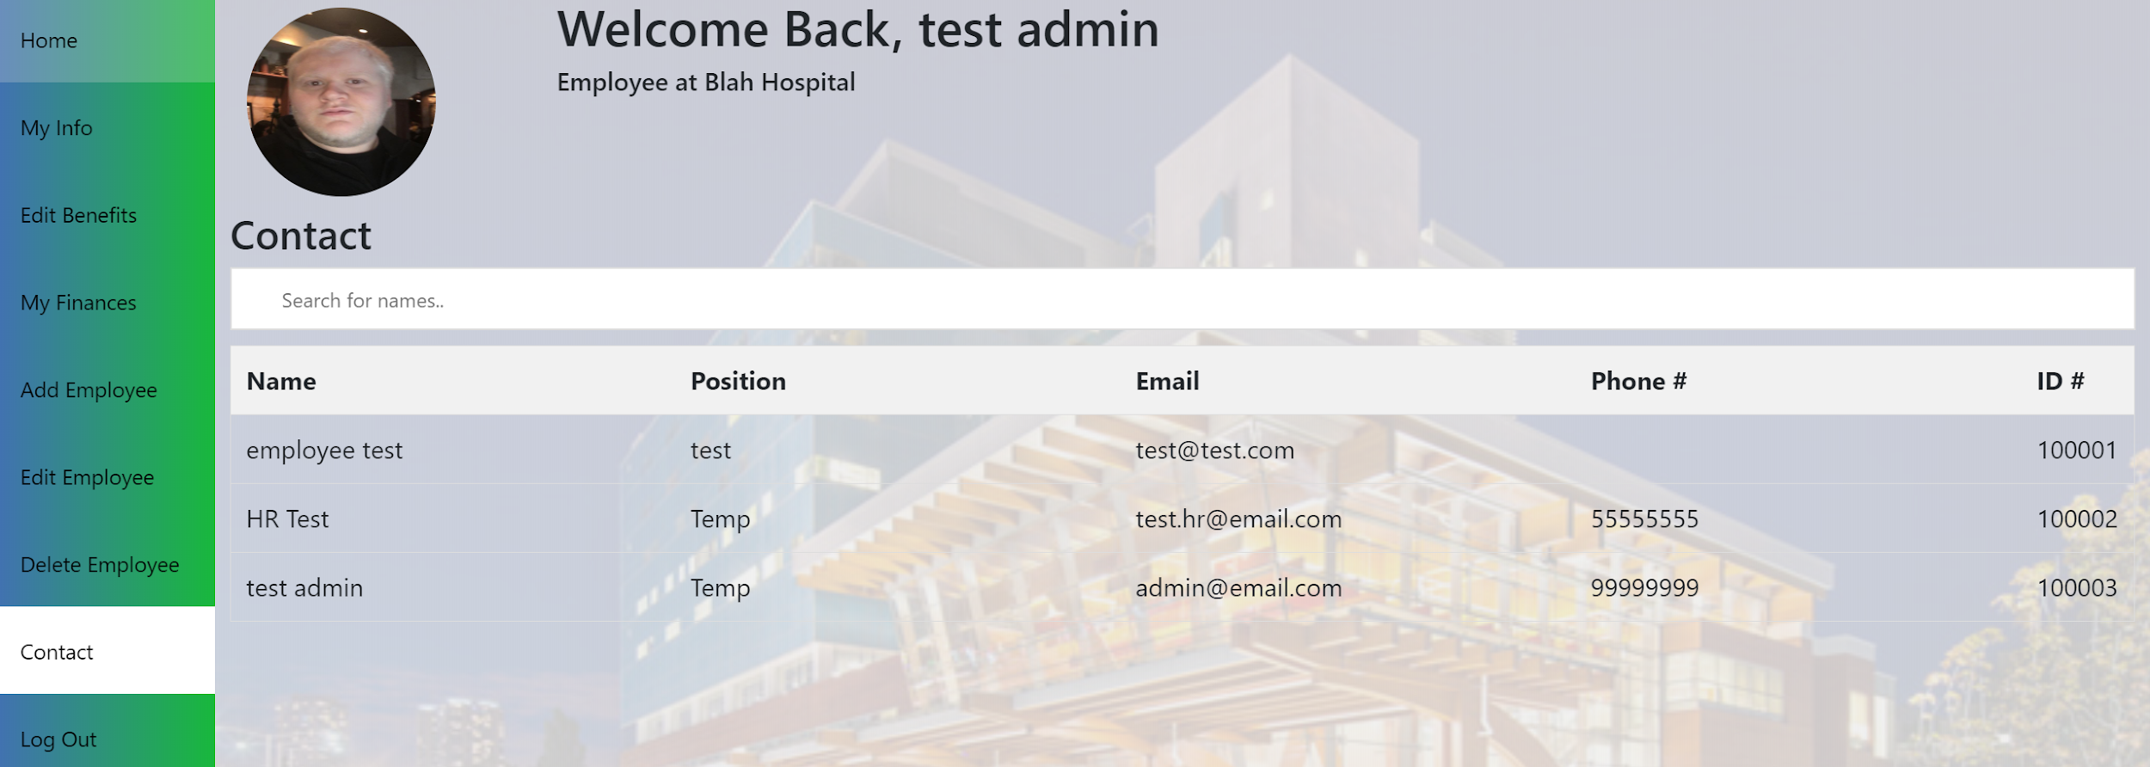

**Figure 4.** Contact-tab

**3.4 Exit System**

Medical Express can be closed by clicking on the logout button.

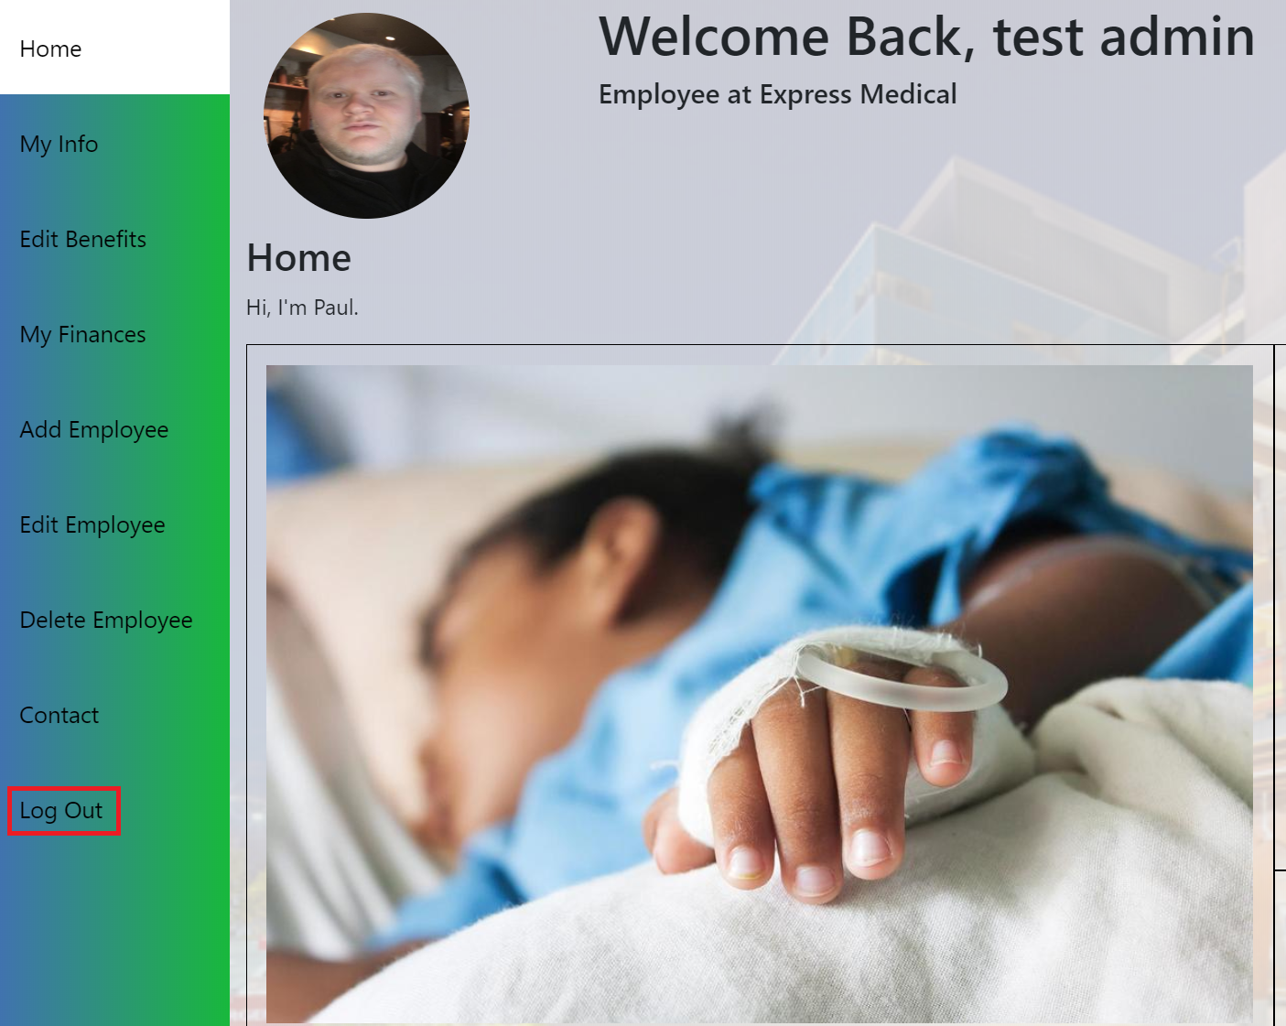

**Figure 5.** Log Out

4.0 USING THE SYSTEM

**4.0 USING THE SYSTEM**  
  
**4.1 Admin**

**4.1.1 Add Employee**

For your employees, HR-reps, and other administrators to use this software, an account must be made for them by an admin or an HR-rep.

There are fourteen fields you must fill in to successfully add a person into the system. These fields are: first name, last name, date of birth, email, address, city, state, zip, password, password confirmation, social security number, social security number confirmation, position in the company, and phone number. An employee’s username is always their last name followed by their ID number. Their ID number is auto-incrementing from a random starting point. Their ID number can be found on the contact page after searching for the employee. The type of person needs to be noted because based on your type, you get certain access to this software.

**4.1.2 Edit Employee**

An employee must be searched by ID number. If the ID number entered is not in the database, then a message will display “0 results” above the search bar. If the employee is found in the database a menu similar to Add Employee will be displayed with the searched employees information already filled out.

**4.1.2 Edit Benefits**

An employee must be searched by ID number. If the ID number entered is not in the database, then a message will display “0 results” above the search bar. If the employee is found in the database a menu will appear allowing for their benefits to be edited. Every benefit should be filled in with a number for the employees “tiered” benefit. By default, everything will be filled with 0’s the first time edited.

**4.1.4 Delete Employee**

An employee must be searched by ID number. If the ID number entered is not in the database, then a message will display “0 results” above the search bar. If the employee is found in the database they can be deleted from the database.

**4.1.5 Contact**

A person can be searched for in five different ways: name, position, email, phone number, or ID number.

Entering this page, you will see a search by dropdown. From there, your search results will match what you’re searching by. Results will be displayed on the table below the search bar. If your search doesn’t match any column, then a message will display “0 results”.

**4.5 Special Instructions for Error Correction**  
  
All errors are explained in the trainer's manual in great detail. Following our exact steps should help get you out of the error message you currently have.